**1).What is Power BI and how does it differ from Excel?**

ANS:- Power BI is a suite of business analytics tools developed by Microsoft that helps organizations visualize their data and share insights. It allows users to create interactive reports and dashboards, perform data analysis, and make data-driven decisions. Power BI connects to a wide range of data sources, transforms the data, and allows users to create visual reports and interactive dashboards.

**Power BI is typically used for:**

* **Data visualization**: Creating rich, interactive reports and dashboards.
* **Data modeling**: Transforming raw data into meaningful insights with the use of relationships, calculations, and other features.
* **Data sharing and collaboration**: Easily sharing reports and dashboards with others, allowing for real-time collaboration.
* **Data exploration**: Diving deeper into data through slicers, filters, and drill-through capabilities.

**How Does Power BI Differ from Excel?**

While both Power BI and Excel are powerful tools for analyzing and visualizing data, there are several key differences:

1. **Purpose**:
   * **Excel** is primarily a spreadsheet tool used for data entry, analysis, and calculations. It's widely used for individual tasks, quick analysis, and data manipulation.
   * **Power BI**, on the other hand, is a business intelligence (BI) tool designed for creating interactive reports, dashboards, and visualizations for organizational-level analysis and decision-making.
2. **Data Handling**:
   * **Excel** is ideal for working with smaller datasets and provides basic visualization tools (charts, pivot tables).
   * **Power BI** is optimized for handling large datasets and can connect to various data sources, including cloud services, databases, and APIs, for more comprehensive and scalable reporting.
3. **Data Visualization**:
   * **Excel** offers basic charts, graphs, and pivot tables, but the visualizations are static.
   * **Power BI** offers a wide range of dynamic, interactive visualizations, including custom visuals, drill-downs, slicers, and more advanced features for user interaction.
4. **Collaboration**:
   * **Excel** files can be shared and worked on by others, but collaboration features are more limited (especially in terms of real-time sharing).
   * **Power BI** provides built-in cloud-based collaboration features, allowing users to share and collaborate on reports and dashboards in real-time through Power BI Service.
5. **Data Modeling**:
   * **Excel** allows for basic data manipulation and calculations using formulas and pivot tables, but it does not offer advanced data modeling capabilities.
   * **Power BI** supports advanced data modeling, including creating relationships between tables, defining complex measures using DAX (Data Analysis Expressions), and working with Power Query for data transformation.
6. **Automation**:
   * **Excel** can automate tasks using macros (VBA), but these are limited in scope and complexity.
   * **Power BI** supports scheduled data refreshes, ensuring that dashboards and reports are always up to date. Additionally, Power BI integrates with other automation tools like Power Automate.
7. **Ease of Use**:
   * **Excel** is more familiar to users and easier for basic tasks and simple analysis.
   * **Power BI** has a steeper learning curve but is designed to be more intuitive for creating complex reports and dashboards once you become familiar with its features.

**Summary:**

* **Excel** is great for individual, detailed data analysis and is ideal for smaller datasets and spreadsheet-based work.
* **Power BI** is designed for creating interactive, enterprise-level reports and dashboards with dynamic visualizations, better handling of large datasets, and more powerful data modeling and sharing capabilities.

**2). Explain the concept of data modeling in Power BI**.

ANS:- Data modeling in Power BI refers to the process of structuring and organizing data in a way that facilitates efficient analysis, reporting, and visualization. It involves defining relationships between different data sources, creating calculated fields, and organizing data into tables and hierarchies to make the reporting process more insightful and meaningful.

The goal of data modeling in Power BI is to ensure that your data is clean, well-structured, and optimized for reporting, enabling users to explore and analyze data easily through interactive visualizations.

**Key Concepts of Data Modeling in Power BI**

1. **Tables**:
   * **Tables** are the basic building blocks of a Power BI data model. A table represents a collection of data, usually from a single source, such as a database, Excel file, or API.
   * Tables can contain **columns** (fields) with data, such as sales amounts, dates, or customer names.
2. **Relationships**:
   * In Power BI, tables can be connected to one another via **relationships**. A relationship allows Power BI to link different tables based on a shared key or field, which helps integrate data from different sources.
   * The most common type of relationship is a **one-to-many** relationship (e.g., a single customer can have multiple orders).
   * Relationships can be created automatically when you import data, or they can be manually defined in the **Model view**.
   * Types of relationships:
     + **One-to-Many**: One record in one table corresponds to many records in another.
     + **Many-to-Many**: Multiple records in one table correspond to multiple records in another.
     + **One-to-One**: A record in one table corresponds to exactly one record in another.
3. **Primary and Foreign Keys**:
   * In a relational database, **primary keys** are unique identifiers for rows in a table, and **foreign keys** are fields in one table that link to primary keys in another table.
   * For example, a **Customer ID** in an Orders table might be a foreign key that links to the **Customer ID** in the Customers table.
4. **Star Schema and Snowflake Schema**:
   * **Star Schema**: This is a popular design pattern in data modeling for Power BI, where a central **fact table** (containing quantitative data like sales or transactions) is connected to multiple **dimension tables** (describing characteristics like products, customers, or time).
   * **Snowflake Schema**: Similar to the star schema, but the dimension tables are normalized (split into additional tables to reduce redundancy), creating a more complex structure.
5. **Fact Tables**:
   * A **fact table** contains numeric data or metrics that represent business transactions (e.g., sales amount, quantity sold, etc.).
   * Fact tables are typically placed at the center of the schema and are linked to dimension tables.
   * They often contain **measures** (aggregated values such as sums, averages, or counts).
6. **Dimension Tables**:
   * **Dimension tables** contain descriptive information about the data in the fact table, like customer details, product information, or time periods.
   * These tables allow users to slice and filter data in meaningful ways (e.g., sales by customer, product, or time).
7. **Calculated Columns and Measures**:
   * **Calculated Columns**: These are new columns created by applying expressions or formulas to existing data within a table. For example, a calculated column can combine first name and last name to create a full name.
   * **Measures**: Measures are calculations performed on data, usually in the form of aggregations like sum, average, or count. Measures are often created using **DAX (Data Analysis Expressions)** and are used to calculate values on the fly based on the context in reports and dashboards (e.g., total sales, average revenue, or growth percentage).
8. **Hierarchies**:
   * **Hierarchies** are used to structure data in a way that enables users to drill down into more detailed levels of information. Common hierarchies include time (Year > Quarter > Month > Day) or geography (Country > State > City).
   * You can create hierarchies in Power BI to organize dimensions like time or geography and allow users to explore data at different levels.
9. **Power Query and Data Transformation**:
   * **Power Query** is the tool within Power BI used to extract, clean, and transform data before loading it into the data model.
   * You can use Power Query to remove duplicates, handle missing values, filter rows, merge tables, and apply other transformations to ensure the data is clean and structured before building the model.
10. **Optimization and Performance**:
    * Efficient data modeling is crucial for the performance of Power BI reports. Large datasets and complex models can cause reports to load slowly or become unresponsive.
    * Techniques like **aggregating data**, **using star schema**, and reducing the number of relationships and calculated columns can help optimize performance.
    * Power BI also supports **DirectQuery** and **Import** modes for data connection, which affects how the data is queried and stored, influencing performance.

### Steps in Building a Data Model in Power BI

1. **Import Data**: Load your data from different sources into Power BI (Excel, SQL Server, web services, etc.).
2. **Transform Data**: Use Power Query to clean, transform, and shape the data. This includes removing duplicates, handling null values, changing data types, and combining tables.
3. **Define Relationships**: Create relationships between the tables to link them logically, ensuring accurate data analysis.
4. **Create Calculated Columns and Measures**: Define calculated columns and measures to create custom metrics or data transformations using DAX.
5. **Build Visualizations**: Once the data model is built, you can use the data in the report view to create charts, tables, and other visualizations.
6. **Optimize and Test**: Optimize the model for performance and ensure it provides the correct insights. Test it by interacting with your reports to ensure that the data is responding as expected.

**3).What are the different types of connections available in Power BI?**

### ANS:- Summary of Connection Types:

1. **Import Mode**: Data is imported and stored in Power BI.
2. **DirectQuery Mode**: Data remains in the source, queried live by Power BI.
3. **Live Connection Mode**: Connected to sources like SSAS or other shared datasets with no data import.
4. **Dataflow**: Data preparation and transformation within Power BI.
5. **On-Premises Data Gateway**: Connects Power BI to local (on-prem) data sources.
6. **Web (API)**: Fetches data via web services or REST APIs.
7. **Excel and CSV Files**: Connects to local and cloud-based file systems.
8. **Cloud-Based Sources**: Direct connections to cloud services like Azure SQL or Salesforce.
9. **Power BI Service Datasets**: Reuse datasets already published in the Power BI service.

Power BI’s flexible connection options make it adaptable to various data sources, whether cloud-based, on-premises, or file-based, providing different ways to access, query, and visualize data.

**4).How do you handle data transformation in Power BI?**

ANS:- In Power BI, data transformation is handled using **Power Query Editor**. Key steps include:

1. **Filtering Rows**: Remove duplicates, filter data based on conditions.
2. **Changing Data Types**: Ensure columns have the correct data types (e.g., number, date).
3. **Adding/Removing Columns**: Create calculated columns or remove unnecessary ones.
4. **Merging/Appending Queries**: Combine data from multiple tables using merge or append.
5. **Splitting/Combining Columns**: Split columns by delimiters or combine multiple columns.
6. **Grouping/Aggregating**: Group data by columns and apply aggregate functions (sum, average).
7. **Pivot/Unpivot**: Reshape data from wide to long format or vice versa.
8. **Handling Null Values**: Replace or remove null values.
9. **Advanced Custom Transformations**: Use M code for complex transformations.

After transformation, load the data into Power BI for analysis and visualization.

**5).What is DAX (Data Analysis Expressions) and why is it important in Power BI?**

### ANS:- DAX (Data Analysis Expressions) is a formula language used in Power BI, Excel, and other Microsoft tools to define custom calculations and queries on data models. It is primarily used for creating measures, calculated columns, and calculated tables in Power BI.

DAX is similar to Excel formulas but specifically designed for handling data analysis in relational databases and models. It operates over columns and tables, allowing users to create dynamic, context-aware calculations, especially when working with large datasets.

**Why is DAX Important in Power BI?**

1. **Data Calculations**: DAX allows users to create custom calculations that are not available by default, such as **aggregations**, **ratios**, **growth percentages**, and more. For example, you can calculate **total sales**, **profit margins**, or create **time intelligence** calculations like **year-over-year growth**.
2. **Context-Dependent Calculations**: DAX can perform calculations based on the **context** of filters, slicers, and visualizations. This allows the same measure to give different results depending on the report's filter context (e.g., sales by region, time period, or product).
3. **Powerful Aggregations**: DAX is great for complex aggregations, such as **SUM**, **AVERAGE**, **COUNT**, and even more complex functions like **CALCULATE**, which allows modifying the filter context for dynamic calculations.
4. **Time Intelligence**: DAX provides built-in functions for **date and time analysis**, such as calculating year-to-date (YTD), month-to-date (MTD), **quarter-over-quarter growth**, and more, which are essential for business reporting.
5. **Improves Interactivity**: Measures created with DAX are recalculated in real-time based on the user’s interactions with visuals and filters, making reports more interactive and responsive.
6. **Advanced Modeling**: DAX allows for the creation of sophisticated models that require calculated columns, relationships, and hierarchies, giving users flexibility in building their reports and dashboards.

**Key Examples of DAX Functions:**

* **SUM()**, **AVERAGE()**, **MIN()**, **MAX()**
* **CALCULATE()**: Modifies the context of a calculation.
* **IF()**, **SWITCH()**: Logical functions for creating conditional logic.
* **DATEADD()**, **TOTALYTD()**: Time intelligence functions for date-based calculations.

**Summary:**

DAX is crucial in Power BI because it enables dynamic, context-sensitive calculations that transform raw data into valuable insights, making it a powerful tool for creating custom metrics, advanced aggregations, and time-based analysis. It is essential for building interactive and responsive reports.

**6).Can you explain the difference between calculated columns and measures in Power BI?**

**ANS:- Difference Between Calculated Columns and Measures in Power BI:**

1. **Calculated Columns**:
   * **Definition**: A **calculated column** is a new column that you add to your data model using a DAX expression. It performs row-by-row calculations and stores the result in the data model.
   * **Storage**: The values in calculated columns are **stored** in the data model, meaning they are computed once when the data is loaded or refreshed.
   * **Use Case**: Calculated columns are useful when you need to create new data that can be used as a field in visualizations, slicers, or for creating relationships between tables.
   * **Example**:
     + Creating a **FullName** column by combining the **FirstName** and **LastName** columns.
     + FullName = [FirstName] & " " & [LastName]
   * **Impact on Performance**: Since calculated columns are stored in the model, they can increase the file size and affect the performance, especially with large datasets.
2. **Measures**:
   * **Definition**: A **measure** is a calculation that is performed **on the fly** based on the context of the report (such as filters or slicers). Measures are used to perform dynamic aggregations and calculations that change depending on the data context (e.g., by region, time period, or product).
   * **Storage**: Measures are not stored in the data model; instead, they are **calculated dynamically** at query time whenever a user interacts with a report (e.g., filters or slicers).
   * **Use Case**: Measures are ideal for aggregating and summarizing data, like calculating **total sales**, **average profit**, **growth percentages**, etc. They are used in **visualizations** to show key metrics.
   * **Example**:
     + Calculating **Total Sales**: Total Sales = SUM(Sales[Amount])
     + Calculating **Profit Margin**: Profit Margin = DIVIDE(SUM(Sales[Profit]), SUM(Sales[Amount]))
   * **Impact on Performance**: Since measures are calculated dynamically, they don’t impact the storage size and are usually more efficient in terms of memory.

**Key Differences:**

|  |  |  |  |  |  |  |  |  |  |  |  |  |  |  |  |  |  |  |
| --- | --- | --- | --- | --- | --- | --- | --- | --- | --- | --- | --- | --- | --- | --- | --- | --- | --- | --- |
| |  |  |  | | --- | --- | --- | | Feature | Calculated Column | Measure | | Computation | Row-by-row calculation during data load/refresh. | Calculated dynamically based on report context. | | Storage | Stored physically in the data model. | Not stored; computed on demand in the report. | | Context | Evaluated in **row context**. | Evaluated in **filter context**. | | Use Case | For creating new columns with fixed values for each row. | For aggregating data (e.g., sum, average) based on the report’s context. | | Performance | Can consume more memory due to storage of values. | More efficient for aggregations, as they are calculated on the fly. | |

**Summary:-**

* row calculations that are stored in the model.
* **Measures**: Used for dynamic calculations that respond to the context of reports (filters, slicers, etc.) and are not stored in the model.

**7).How do you handle relationships between tables in Power BI?**

ANS:- In Power BI, relationships between tables are handled through the **Data Model**. Relationships define how data in different tables are connected and ensure that data can be accurately analyzed and visualized across multiple tables. Here's how relationships are handled:

**1. Types of Relationships:**

Power BI supports three types of relationships between tables:

* **One-to-One (1:1)**: Each row in one table is related to one row in another table.
* \**One-to-Many (1:* or Many-to-One)**: One row in the "one" table is related to multiple rows in the "many" table. This is the most common type of relationship.
* **Many-to-Many (*:*)**: Multiple rows in one table can be related to multiple rows in another table.

**2. Creating Relationships:**

* Go to the **Model** view in Power BI.
* Drag a field (usually the primary key in one table) and drop it onto the related field (usually a foreign key) in the other table to create a relationship.
* You can also manually define relationships by clicking on **Manage Relationships** in the **Modeling** tab, and setting up relationships via a dialog box.

**3. Cardinality:**

Cardinality defines the nature of the relationship:

* **Single**: Each table can have only one direction for the relationship.
* **Both**: The relationship can be navigated in both directions (useful for some complex data models).

**4. Relationship Direction:**

* **Single Direction**: This means that filtering in one table will propagate to the related table in only one direction (e.g., from a "Sales" table to a "Product" table).
* **Both Directions**: In some cases, you might need to set relationships to flow in both directions, especially for complex models with multiple related tables. This enables filters to propagate in both directions.

**5. Managing Relationships:**

* Power BI allows you to manage the relationships via the **Manage Relationships** option, where you can edit, delete, or create new relationships.
* You can also define the **relationship type** (e.g., active or inactive), and if you have multiple relationships between the same two tables, you can define which one is the **active** relationship.

**6. Handling Multiple Relationships:**

* If there are multiple relationships between two tables (for example, two possible keys to join them), Power BI will allow you to set one as the **active** relationship and others as **inactive**. Inactive relationships can be used in DAX formulas (like USERELATIONSHIP) when needed.

**7. Cross-Filtering:**

* Cross-filtering is the process where selecting a value in one table filters the related values in another table. Power BI allows you to define how cross-filtering works (both or single direction) when creating relationships.
* Power BI also supports **bidirectional cross-filtering**, where both tables can filter each other simultaneously. However, caution is needed because it can sometimes lead to circular dependencies or performance issues.

**8. Role-Playing Dimensions:**

* You can have a **role-playing dimension** where the same dimension table is related to a fact table multiple times in different roles. For example, a **Date** table might be used as the "Order Date," "Ship Date," or "Delivery Date" in different contexts, and each relationship would be handled accordingly.

**9. Relationship with Calculated Tables:**

* Power BI allows you to create calculated tables, which can also have relationships with other tables. These calculated tables can be created using DAX expressions.

**Best Practices:**

* **Modeling Star Schema**: It's recommended to design your data model in a star schema, where you have fact tables connected to dimension tables via one-to-many relationships.
* **Minimize Bi-directional Filters**: Use bi-directional relationships carefully to avoid complexity or performance issues.
* **Ensure Data Consistency**: Make sure that the fields used to create relationships (e.g., keys) are of consistent data types and have matching values.

By setting up and managing these relationships, you enable Power BI to efficiently model and analyze data across multiple tables and provide accurate reports and visualizations.

**8).What is the purpose of a Power BI Gateway**?

ANS:- A **Power BI Gateway** serves as a bridge between **on-premises data sources** and **Power BI** (or other Microsoft cloud services like Power Apps and Power Automate). It enables users to securely access and refresh data from local (on-premises) databases, files, and other data sources without needing to manually move or upload that data to the cloud. The primary purpose is to ensure that data stored on-premises is regularly updated and synced with Power BI reports and dashboards in a secure and automated way.

Here’s a breakdown of the key purposes and functionalities of the Power BI Gateway:

**1. Data Connectivity:**

The Power BI Gateway facilitates **secure data transfer** between **on-premises data sources** (e.g., SQL Server, Oracle, Excel files, etc.) and **Power BI in the cloud**. This allows for real-time or scheduled data refreshes in Power BI reports and dashboards, ensuring the reports reflect up-to-date information.

**2. Secure Data Transfer:**

The gateway ensures that data transferred from on-premises systems to Power BI (or `other services) is encrypted and secure. It uses **SSL encryption** for secure communication between the on-premises environment and the cloud.

**3. Scheduled and On-Demand Data Refresh:**

The Power BI Gateway allows for automatic or **scheduled data refreshes**. This means you can set up a refresh schedule for your Power BI datasets, ensuring that the data stays updated without manual intervention. It also supports **on-demand refresh** for immediate updates when needed.

**4. Support for On-Premises Data Sources:**

The gateway enables Power BI to connect to a variety of **on-premises data sources** such as:

* SQL Server
* Oracle Database
* SharePoint Server
* File-based data (e.g., Excel, CSV)
* Analysis Services (SSAS) and more.

Without the gateway, Power BI can only connect to cloud-based data sources.

**5. Access to Local Services and Enterprise Data:**

The Power BI Gateway allows organizations to keep their **sensitive data on-premises** while still taking advantage of cloud-based Power BI reporting. This is particularly useful for businesses with **strict data governance** or compliance requirements, where keeping certain data on-premises is essential.

**6. Support for Hybrid Data Models:**

Power BI users can use the gateway to set up **hybrid data models**, where some data comes from on-premises sources, while other data resides in the cloud. This allows for more flexible reporting and analytics across a variety of data locations.

**7. Two Types of Gateways:**

* **Personal Gateway**: This is primarily for individual use and is installed on a user’s local machine. It is suitable for users who need to refresh their personal reports or datasets.
* **Enterprise Gateway**: This is more robust and designed for larger organizations with multiple users. It supports centralized management and data refreshes for the entire organization and can be installed on a server to handle large-scale deployments.

**8. Data Privacy and Governance:**

By using the Power BI Gateway, organizations maintain greater **control over their data**. Since the data stays within their network and isn't uploaded to the cloud, they can maintain better privacy, security, and compliance standards.

**9. Support for DirectQuery and Live Connections:**

The Power BI Gateway also supports **DirectQuery** and **Live Connection** modes, meaning that the data does not need to be imported into Power BI; instead, queries are run directly against the on-premises data source. This is particularly useful for very large datasets or real-time reporting requirements.

**10. Integration with Other Services:**

* The gateway isn't just limited to Power BI; it also integrates with other Microsoft services such as **Power Apps** and **Power Automate**, allowing for similar secure connectivity and data refresh capabilities with those services as well.

**11. Centralized Management and Monitoring:**

The **Power BI Gateway** provides a **centralized management interface**, where administrators can monitor the status, performance, and activity of the gateway, as well as manage user access and security settings. This helps ensure smooth and efficient operation of data refresh schedules and connectivity.

**12. Cloud and On-Premises Data Integration:**

The Power BI Gateway enables organizations to integrate cloud-based and on-premises data sources in the same reports, facilitating seamless analytics across different environments.

**In Summary:**

The Power BI Gateway allows organizations to connect their **on-premises data** to **cloud-based Power BI** reports, providing a **secure, automated, and scalable solution** for accessing, refreshing, and visualizing on-premises data without moving it to the cloud. It enables hybrid data models, ensures compliance with security standards, and provides reliable data refresh schedules for accurate reporting and decision-making.

**9).How can you schedule data refresh in Power BI Service?**

ANS:- To schedule data refresh in **Power BI Service**, follow these steps:

**1. Publish the Report/Dataset:**

* First, make sure your **Power BI report or dataset** is published to the Power BI Service (cloud).

**2. Go to Dataset Settings:**

* In the Power BI Service, navigate to the workspace where your dataset is located.
* Find the dataset you want to refresh and click the **"More options"** (three dots) next to it.
* Select **Settings**.

**3. Configure Data Source Credentials:**

* Under the **Dataset Settings**, go to the **Data source credentials** section and ensure that valid credentials are set up for the data sources.
* If necessary, enter the required credentials (e.g., username, password) to access the data.

**4. Set the Scheduled Refresh:**

* In the **Scheduled refresh** section, toggle the **Keep data updated** switch to **On**.
* Set the **Refresh frequency** (Daily, Weekly, etc.) and select the **time** for the refresh.
* Specify the **time zone** for the refresh schedule.

**5. Save Settings:**

* After configuring the refresh schedule, click **Apply** to save your settings.

**6. Monitor Refresh Status:**

* You can monitor the refresh status from the **Refresh History** section within the dataset settings to ensure the refreshes are happening as scheduled.

By following these steps, your dataset in Power BI Service will automatically refresh according to the schedule you’ve set, ensuring your reports always show up-to-date data.

**10). Explain the concept of row-level security in Power BI.**

ANS:- **Row-level security (RLS)** in Power BI is a feature that allows you to restrict access to specific rows in a dataset based on the **user's role** or **identity**. This means different users can see different subsets of the same data in Power BI reports and dashboards, ensuring that sensitive or confidential data is only visible to the appropriate individuals.

**Key Concepts of Row-Level Security:**

1. **Roles and DAX Filters**:
   * In Power BI, RLS is implemented by creating **roles** in the Power BI Desktop, where each role has a **DAX filter** applied to the data. These filters control which rows of data each role can access.
   * For example, you might create a role for "Sales Managers" that only sees data for their region, while another role, "HR," only sees employee data.
2. **Creating Roles**:
   * In Power BI Desktop, you can create roles under the **Modeling** tab by clicking **Manage Roles**.
   * For each role, you can define filters using **DAX expressions** to limit the rows that each role can access. For example, a DAX expression might restrict data to only a specific department or region.
3. **Dynamic Filtering**:
   * RLS can also be **dynamic**, meaning the data a user sees can change based on their **login credentials**. For instance, you could set up a dynamic filter based on the user's **Active Directory group** or username, which ensures users only see the data they’re allowed to access.
4. **Testing RLS**:
   * Power BI Desktop allows you to test the RLS setup by using the **View as Role** feature, where you can simulate what a report would look like for different roles.
5. **Publishing and Assigning Roles in Power BI Service**:
   * After setting up RLS in Power BI Desktop, you need to publish the report to the **Power BI Service**.
   * In the Power BI Service, you can assign users to the roles you created. Only users assigned to specific roles will see the filtered data when they view the report.
6. **Security at the Row Level**:
   * Row-level security helps control access **at a granular level**, ensuring users only see data relevant to them (e.g., sales data for their region, employee data for their department, etc.).
   * This is particularly useful in scenarios where a report contains data from multiple departments or regions, but each department or region should only see its own data.

**Example Scenario:**

* A sales manager for the "East" region should only see sales data for that region.
* Using RLS, you can create a role called **East Sales Manager** with a DAX filter like:
* [Region] = "East"
* Any user assigned to the "East Sales Manager" role will only see rows where the **Region** is "East."

**Benefits of RLS:**

* **Data Security**: Ensures users only see the data they're authorized to view.
* **Centralized Control**: You can manage and control access directly within the Power BI report without needing to modify the underlying data.
* **Efficient Use of Reports**: One report can be used by many different users with varying data access levels.

In summary, **Row-level security** allows you to restrict access to specific data rows in Power BI based on user roles, ensuring that users only see data that is relevant and authorized for them. This enhances both security and usability of reports across different user groups.

**11).What is the Power BI Desktop and how does it differ from Power BI Service?**

**ANS:- Power BI Desktop** and **Power BI Service** are both key components of the Power BI ecosystem, but they serve different purposes and offer different functionalities.

### ****Power BI Desktop****:

**Power BI Desktop** is a **Windows application** used for **creating reports and data models**. It is primarily intended for **report authors** (data analysts, developers) who design, build, and publish reports. It is a free, desktop-based application that provides powerful data transformation, visualization, and modeling tools.

### ****Power BI Service****:

**Power BI Service** is a cloud-based platform for **publishing, sharing, collaborating, and consuming reports and dashboards**. It provides a collaborative environment where users can interact with reports and dashboards that have been shared with them, schedule data refreshes, and manage datasets.

**Key Differences Between Power BI Desktop and Power BI Service**:

|  |  |  |  |  |  |  |  |  |  |  |  |  |  |  |  |  |  |  |  |  |  |  |  |  |  |  |  |  |  |  |
| --- | --- | --- | --- | --- | --- | --- | --- | --- | --- | --- | --- | --- | --- | --- | --- | --- | --- | --- | --- | --- | --- | --- | --- | --- | --- | --- | --- | --- | --- | --- |
| |  |  |  | | --- | --- | --- | | Feature | Power BI Desktop | Power BI Service | | Purpose | Report creation, data modeling, and visualization | Cloud-based viewing, sharing, and collaboration | | Installation | Desktop application (Windows only) | Cloud service (web-based) | | Data Refresh | No automatic refresh; manual data load in Desktop | Supports **scheduled data refresh** | | Publishing | Used to **create** reports, then publish to Service | Used to **view** and **share** reports | | Collaboration | No collaboration features; **single user** use | Supports **team collaboration**, sharing, and permissions | | Data Modeling | Allows **advanced data modeling** using Power Query and DAX | Limited data modeling, but can manage datasets | | Storage | Files saved as .pbix on local machine | Cloud-based storage, part of Power BI workspace | | Access | Only accessible on the local machine | Accessible from any device with internet access | | Roles | Primarily for **developers** creating reports | Primarily for **viewers** and **collaborators** | |

**12).Explain the concept of Direct Query in Power BI?**

**ANS:- DirectQuery** in Power BI allows users to connect directly to an external data source without importing data into Power BI. Instead of storing data within Power BI, queries are sent to the data source in real-time whenever a user interacts with a report. This mode is ideal for scenarios where the data is too large to import, or when real-time access to up-to-date information is required.

In DirectQuery mode, Power BI sends queries to the underlying data source for every filter, interaction, or visual update in a report. This ensures that users always see the most current data available, without the need to schedule data refreshes. However, performance depends on the responsiveness and speed of the data source, as large or complex queries can impact performance.

While DirectQuery avoids importing data, it has limitations in terms of data transformation capabilities, as complex transformations are not supported in the same way as with imported data. Additionally, not all data sources support **query folding**, which could impact performance.

**13).What are Power BI templates and how are they useful?**

**ANS:- Power BI Templates** are pre-configured report files in Power BI that allow you to reuse the same layout, structure, and visuals for different datasets. They save time by enabling users to quickly create reports without starting from scratch each time.

**How Power BI Templates Are Useful:**

1. **Standardization:**
   * Templates ensure consistency across multiple reports, dashboards, or projects. This is especially useful in organizations where multiple users create reports that need to follow a consistent design or layout.
2. **Time-saving:**
   * Instead of creating the same report from scratch every time, you can use a template and just replace the data source. This drastically reduces the time spent on formatting and designing the report.
3. **Reusable Design:**
   * You can save your best-performing reports or visualizations as templates and reuse them across different datasets or clients, which helps in maintaining consistency and reducing effort.
4. **Customization:**
   * While templates provide a standard structure, they still allow users to customize the visuals, data sources, and other elements as per specific needs.
5. **Easy Sharing:**
   * Templates can be shared within an organization or community, enabling easy dissemination of best practices, visual styles, and report structures.
6. **Efficient for Different Data Sources:**
   * Templates are especially useful when you are dealing with the same type of data (e.g., sales, finance, etc.) across different sources. You can create one template, and it can be applied to any new dataset with similar data fields.

**How to Use a Power BI Template:**

1. **Create a Template:**
   * Once you’ve built a report with visuals and connected it to your data sources, you can save the file as a template. This will save the structure without saving the underlying data.
2. **Use a Template:**
   * When you open a template file, you will need to connect it to a new dataset or modify the data sources to fit your needs. The visuals and layout remain intact.

In summary, Power BI templates are an excellent way to streamline reporting processes, maintain consistency, and optimize time and resources.

**14).How do you handle incremental data refresh in Power BI?**

**ANS:- Handling Incremental Data Refresh in Power BI** is a crucial technique to optimize performance, particularly when working with large datasets. Incremental refresh allows you to refresh only the new or updated data, rather than refreshing the entire dataset, which can save time and resources.

To handle **incremental data refresh** in Power BI:

1. **Prepare Data Model**: Ensure your data has a **date or timestamp column** to track changes.
2. **Enable Incremental Refresh**: In Power BI Desktop, right-click the table → **Incremental Refresh** → Configure refresh settings (e.g., keep the last 5 years of data, refresh the last 1 month).
3. **Set Refresh Policy**: Define how much historical data to retain and how often to refresh new data (e.g., daily refresh for recent data).
4. **Publish to Power BI Service**: After setting up in Desktop, publish to Power BI Service and configure **scheduled refresh**.
5. **Monitor Performance**: Ensure refresh works as expected and optimize the data source for performance.

This approach reduces refresh times and system load by only updating new or modified data.

**15).What is the role of Power Query in Power BI?**

**ANS:- Power Query** in Power BI is a data connection, transformation, and preparation tool. Its role is essential in importing, cleaning, shaping, and transforming raw data into a format suitable for analysis in Power BI. It helps users prepare data before visualizing it.

**Key Roles of Power Query in Power BI:**

1. **Data Extraction**:
   * Power Query connects to various data sources (e.g., Excel, SQL Server, web, APIs) and imports data into Power BI.
2. **Data Transformation**:
   * It allows users to **clean** and **transform** data by applying a series of transformations (e.g., removing duplicates, changing data types, splitting columns, pivoting data).
3. **Data Shaping**:
   * Power Query helps reshape data to suit reporting needs by filtering, aggregating, or combining tables.
4. **Automation of Data Processing**:
   * Once transformations are set up, Power Query automatically applies them each time new data is loaded, ensuring consistency in data preparation.
5. **M Language**:
   * Power Query uses the **M language** to apply advanced transformations, providing greater flexibility for data manipulation.

In summary, Power Query plays a crucial role in cleaning, shaping, and transforming raw data into a structured format that is ready for analysis in Power BI.

**16).Explain the difference between calculated columns and calculated tables in Power BI.**

ANS:- In Power BI, **calculated columns** and **calculated tables** are both used to create new data based on existing data, but they differ in scope, usage, and how they are applied. Here’s a breakdown of the key differences:

**Calculated Columns:**

* **Definition**: A **calculated column** is a new column added to an existing table that is derived from an expression or formula applied to the data in other columns of the same table.
* **Scope**: It operates on a **row-by-row** basis. Each row in the column gets calculated individually based on the formula.
* **Usage**: Calculated columns are often used for creating new attributes or adding dimensions to the dataset. For example, you might create a calculated column for "Profit" by subtracting "Cost" from "Sales."
* **Storage**: Calculated columns are stored in the data model as part of the table, and their values are computed when data is loaded or refreshed.
* **Example**:
* Profit = Sales[Amount] - Sales[Cost]

**Calculated Tables:**

* **Definition**: A **calculated table** is a new table that is created based on a DAX expression that can reference other tables or data sources. The table is generated from calculations and is not part of the original data set.
* **Scope**: It defines a **whole new table**, typically used for aggregation, filtering, or joining data in different ways.
* **Usage**: Calculated tables are useful when you need to create summary tables, relationships, or filtering tables that weren’t part of the original data model. They are often used for advanced modeling scenarios.
* **Storage**: Calculated tables are also stored in the data model like any other table, and they are recalculated upon data refresh.
* **Example**:
* SalesSummary = SUMMARIZE(Sales, Sales[Region], "Total Sales", SUM(Sales[Amount]))

**Key Differences:**

|  |  |  |  |  |  |  |  |  |  |  |  |  |  |  |  |  |  |  |
| --- | --- | --- | --- | --- | --- | --- | --- | --- | --- | --- | --- | --- | --- | --- | --- | --- | --- | --- |
| |  |  |  | | --- | --- | --- | | Feature | Calculated Column | Calculated Table | | Definition | A new column in an existing table. | A new table created from an expression. | | Scope | Row-by-row calculation. | Whole table creation based on an expression. | | Usage | Used to add new attributes or dimensions. | Used to create summary or filtered tables. | | Storage | Stored as part of the table. | Stored as a separate table in the model. | | Examples | Profit, Age Group, Discount Category | Sales summary, Date table, Filtered table | |

**When to Use:**

* **Use Calculated Columns** when you need to add new columns to an existing table to capture derived values (like a ratio, category, or classification).
* **Use Calculated Tables** when you need to create a table that aggregates, filters, or summarizes data from other tables.

In summary, **calculated columns** add new information to an existing table row by row, while **calculated tables** generate new tables based on specific expressions and can be used for more complex modeling or aggregation.

**17). How do you create custom visuals in Power BI?**

ANS:- To create **custom visuals** in Power BI:

1. **Using Marketplace**:
   * Go to the **Visualizations pane**, click the **three dots** (ellipsis), and select **"Get more visuals"**.
   * Browse the **Power BI Visuals Marketplace**, select and **add** the visual to your report.
2. **Develop Custom Visuals (Advanced)**:
   * Install **Node.js** and **Power BI visuals tools** using npm (npm install -g powerbi-visuals-tools).
   * Create a new visual project with pbiviz new <visual_name>.
   * Develop the visual using **TypeScript** and libraries like **D3.js**.
   * Test locally with pbiviz start.
   * Package with pbiviz package and import the .pbiviz file into Power BI.

This allows you to either import existing custom visuals or create your own from scratch.

18). **What are the best practices for optimizing performance in Power BI?**

ANS:- Here are the **best practices** for optimizing Power BI performance:

1. **Optimize Data Model**:
   * Use **star schema** for simpler models.
   * **Reduce data size** by removing unused columns/rows and using **appropriate data types**.
2. **Efficient DAX**:
   * Use **simple DAX calculations** and avoid complex nested functions.
   * Minimize **row context** and avoid **expensive DAX functions** like CALCULATE or ALL.
3. **Limit Visuals**:
   * Reduce the number of visuals on a report page.
   * Avoid excessive **slicers** and complex visuals.
4. **Use Aggregated Data**:
   * Use pre-aggregated data for large datasets or create **aggregated tables** for faster processing.
5. **Leverage Incremental Refresh**:
   * Use **incremental refresh** to load only new or updated data, not the entire dataset.
6. **Optimize Queries**:
   * Filter data early in **Power Query** to reduce the dataset size.
   * Avoid **complex transformations** during load.
7. **Monitor and Analyze Performance**:
   * Use **Performance Analyzer** and **Query Diagnostics** to identify bottlenecks and improve performance.

By following these practices, you can significantly enhance Power BI performance and improve user experience.

**19). How can you integrate Power BI with other Microsoft products like Azure and Office 365?**

ANS:- To integrate **Power BI** with other Microsoft products like **Azure** and **Office 365**, you`can leverage several powerful features:

**1. Power BI and Azure Integration:**

* **Azure SQL Database & Azure Synapse Analytics**: Connect Power BI directly to **Azure SQL Database** and **Azure Synapse** for real-time or on-demand data analysis and reporting.
* **Azure Data Lake**: Use **Power BI Dataflows** to load and transform data from **Azure Data Lake Storage** for more scalable data preparation.
* **Azure Machine Learning**: Incorporate **Azure ML models** into Power BI reports for advanced machine learning capabilities, such as predictive analytics.
* **Azure Blob Storage**: Directly connect Power BI to **Azure Blob Storage** to import large datasets stored in the cloud.

**2. Power BI and Office 365 Integration:**

* **SharePoint**: Connect to **SharePoint Lists** to pull data into Power BI for detailed reporting and analysis.
* **Excel**: Use **Excel files** stored in **OneDrive for Business** or **SharePoint** as data sources for Power BI. This allows for dynamic, live updates to reports.
* **Microsoft Teams**: Embed **Power BI reports** into **Microsoft Teams** to facilitate collaboration and provide real-time insights to team members directly within the Teams interface.
* **Power Automate**: Use **Power Automate** to trigger workflows, such as data refreshes or alert notifications in Power BI based on certain actions or events.

By integrating Power BI with Azure and Office 365, you enhance reporting, collaboration, data flow, and automation within the Microsoft ecosystem.

**20). Explain the concept of aggregations in Power BI?**

**ANS:- Aggregations in Power BI** refer to the process of summarizing large volumes of detailed data into more manageable, high-level metrics or summaries. This technique is essential for improving performance when working with large datasets by reducing the amount of data Power BI needs to process during queries and visualizations.

**Key Concepts of Aggregations in Power BI:**

1. **Aggregation Tables**:
   * Aggregation tables are pre-summarized tables that contain aggregated data (like sums, averages, or counts) for large datasets.
   * These tables are used to perform faster queries by reducing the need to scan the entire dataset.
   * Aggregation tables are often used in **Power BI Premium** to optimize performance for large datasets.
2. **How Aggregations Work**:
   * Power BI can be set to query the aggregated data instead of the detailed data for some calculations, which speeds up report loading.
   * When a user queries data, Power BI checks whether it can use the aggregated table (if configured) instead of querying the detailed data, making the report faster.
3. **Aggregation Types**:
   * You can define different aggregation types such as **SUM**, **AVERAGE**, **MIN**, **MAX**, **COUNT**, etc., for each column in the aggregation table.
4. **Implementation in Power BI**:
   * **Aggregation Awareness**: Power BI automatically uses the appropriate aggregation when a user interacts with the report (based on the visual's granularity).
   * **Aggregation in Power BI Premium**: Premium users can take advantage of **Aggregation Tables** and configure them in the **Data Model** for optimal performance.
5. **Benefits**:
   * **Improved Performance**: By reducing the amount of detailed data processed, queries are faster.
   * **Efficiency**: Aggregations improve efficiency by handling larger data models and reducing the load on the underlying system.
6. **Example**:
   * If you have sales data for every transaction (with millions of rows), you could create an aggregation table that sums the total sales per **month** or **region**, allowing users to query the summarized data instead of each individual transaction.

**Summary:**

Aggregations in Power BI are used to optimize report performance by summarizing large datasets into high-level metrics. This allows Power BI to query pre-aggregated tables rather than the full detailed data, speeding up report loading and interaction, especially for large datasets.

**21). How do you handle error handling and data quality in Power BI?**

ANS:- Handling **error handling** and ensuring **data quality** in Power BI is crucial for creating reliable and accurate reports. Here are best practices and strategies to handle these aspects effectively:

**1. Error Handling in Power BI**

* **Power Query Error Handling**:
  + **Try & Otherwise**: Use the try ... otherwise function in Power Query to catch errors in data transformation steps and prevent the query from failing. For example:
  + = try [YourExpression] otherwise "Error"

This returns a default value ("Error" in this case) if an expression fails.

* + **Error Replacement**: You can replace errors or null values with default values (e.g., 0 or "Unknown") using the Table.ReplaceErrorValues function in Power Query.
  + **Remove or Flag Invalid Data**: Use **conditional columns** or **filters** to clean data and handle missing or incorrect values. For instance, you can filter out rows with null or invalid values before loading data into the model.
* **DAX Error Handling**:
  + **IFERROR**: Use the IFERROR function in DAX to handle errors in calculated columns or measures:
  + = IFERROR(YourExpression, 0)

This returns 0 (or another default value) if the expression results in an error.

* + **ISBLANK**: Use ISBLANK in DAX to check for blank or null values before performing calculations:
  + = IF(ISBLANK(YourColumn), 0, YourColumn)

**2. Data Quality in Power BI**

* **Data Profiling and Validation**:
  + **Power Query Data Profiling**: Use the **Data Profiling** feature in Power Query to examine the data quality. It provides insights like the number of distinct values, nulls, and value distributions for each column.
  + **Validation Rules**: In Power Query, set up validation rules to ensure the data meets certain quality criteria (e.g., no nulls, values within a specific range).
* **Data Cleaning**:
  + **Remove Duplicates**: Use the **Remove Duplicates** option in Power Query to eliminate duplicate rows from the data.
  + **Data Transformation**: Normalize data formats (e.g., dates, text) to ensure consistency. Use functions like Text.Upper or DateTime.Date in Power Query to standardize data formats.
  + **Handle Missing Data**: Decide how to handle missing or null data, such as filling with default values, removing rows, or interpolating missing values based on business logic.
* **Data Integrity Checks**:
  + **Data Consistency**: Check for data integrity by ensuring that relationships between tables are correct. For example, confirm that foreign key relationships are properly set up in the data model.
  + **Outlier Detection**: Identify and handle outliers that may indicate data quality issues (e.g., values that are too high or low based on business rules).
* **Monitoring and Alerts**:
  + **Set up alerts** in Power BI to notify users of any data issues, such as discrepancies or missing values in the report.
  + **Scheduled Refresh Error Logs**: Monitor **refresh logs** for errors and data load issues to catch any issues during data refreshes.

**3. Best Practices for Data Quality and Error Handling**

* **Data Source Quality**: Ensure that the data sources are reliable and clean. Regularly validate the data source for any inconsistencies or errors before it enters Power BI.
* **Consistent Naming Conventions**: Use consistent naming conventions for columns, tables, and measures to avoid confusion and ensure clarity in reporting.
* **Automated Data Refresh Monitoring**: Set up automated monitoring of data refreshes to ensure that scheduled data updates are completed successfully without errors.

**Summary**

* **Error Handling**: Use try...otherwise in Power Query, IFERROR and ISBLANK in DAX to handle errors and ensure smooth report operation.
* **Data Quality**: Leverage Power Query’s data profiling, data cleaning, validation, and consistency checks to ensure data quality.
* **Best Practices**: Monitor refresh logs, set up alerts, and ensure consistent data sources to maintain reliable reports.

By proactively managing error handling and ensuring data quality, you can build more accurate, reliable, and trustworthy Power BI reports.

**22). What is the purpose of Power BI Embedded and when would you use it?**

**ANS:- Power BI Embedded** allows developers to embed interactive Power BI reports, dashboards, and visualizations into their own applications, websites, or portals. It enables businesses to provide rich, data-driven insights to their users without needing to have Power BI licenses for each individual user.

**Purpose of Power BI Embedded:**

1. **Embed Power BI Content into Applications**:
   * Power BI Embedded allows you to integrate **Power BI reports** and **dashboards** directly into your application interface, providing end-users with access to powerful data visualizations without leaving the application.
2. **White-labeling**:
   * Power BI Embedded enables **white-labeling**, so the embedded content can appear as if it’s part of the application rather than a Power BI product. This is particularly useful for businesses that want to provide analytics without exposing the Power BI branding.
3. **APIs for Customization**:
   * It provides **APIs and SDKs** that developers can use to create custom interactions, apply filters, and control the embedded content programmatically, offering deep customization.
4. **Secure Data Sharing**:
   * Through embedding, you can securely control and manage access to Power BI reports and dashboards, ensuring that only authorized users see the data they are allowed to view, while maintaining data security and privacy.
5. **Scalability**:
   * Power BI Embedded allows you to scale access to reports and dashboards across potentially thousands of users, which can be cost-effective compared to purchasing Power BI Pro licenses for each user.

**When to Use Power BI Embedded:**

1. **Software-as-a-Service (SaaS) Products**:
   * If you are offering a **SaaS** solution, embedding Power BI can provide your users with rich, interactive data visualizations within your application. For example, a CRM or ERP application might embed Power BI to provide analytics features.
2. **Customer-facing Analytics**:
   * Use Power BI Embedded when you need to provide your **customers or external users** with customized reports and dashboards as part of a service you are offering. This is ideal for scenarios where you want users to interact with data but don't want them to log into Power BI separately.
3. **Internal Business Applications**:
   * Businesses building internal tools and custom applications for their teams (e.g., HR, finance, operations) can embed Power BI reports directly into these tools for easy data access and analysis.
4. **Custom Branding and White-Labeling**:
   * If you want to provide analytics without the Power BI branding, and fully customize the look and feel of the reports within your own application or portal, Power BI Embedded offers white-labeling features to achieve this.
5. **Pay-per-User or Subscription Models**:
   * Power BI Embedded is useful for applications with a **pay-per-user model** where users are billed based on consumption of embedded content, making it cost-effective for apps with a large user base that doesn’t require individual Power BI licenses.

**Summary:**

* **Power BI Embedded** allows businesses to integrate Power BI reports and dashboards directly into their own applications or websites, offering customizable, interactive data visualizations.
* It’s especially useful for **SaaS** applications, **customer-facing analytics**, and internal applications, where you want to provide users with data insights without them needing a Power BI license.
* It also offers customization through APIs and secure, scalable data access to ensure the right users see the right data.

Stacked Column Charts

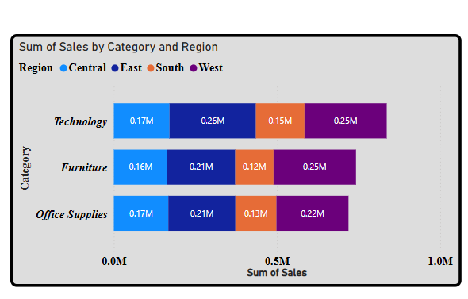

Matrix

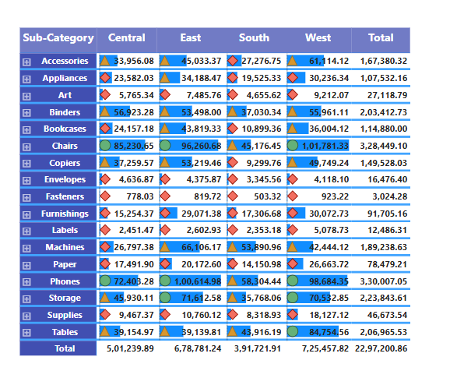

Donut chart

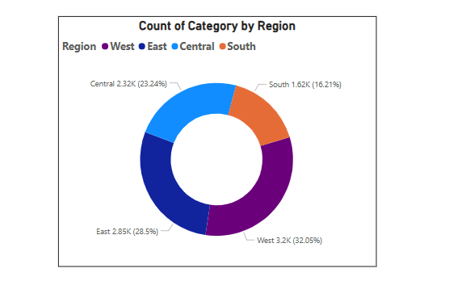

column charts

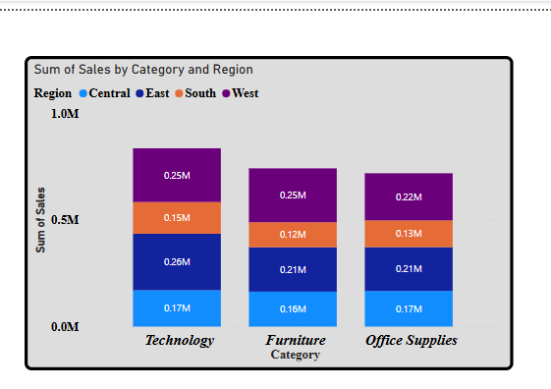

cluster bar charts

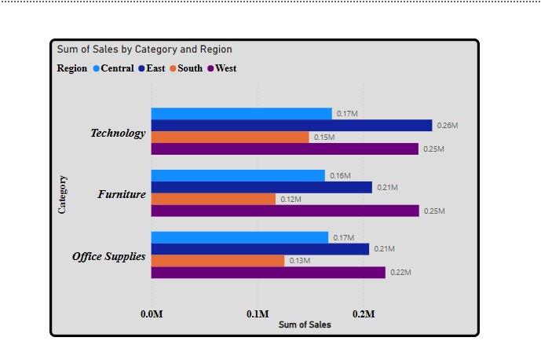

clusted column chrts

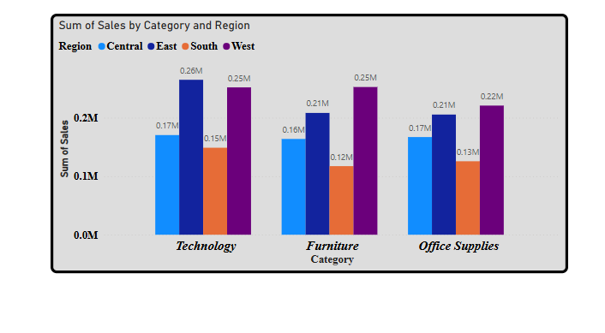

stacked bar chrts

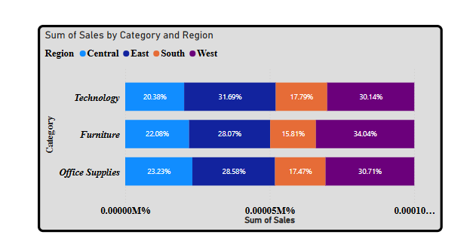

pie charts

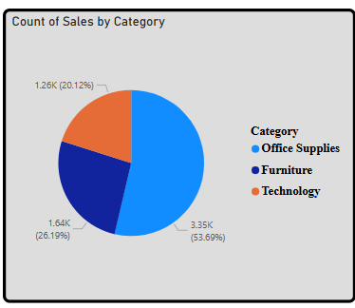

area charts

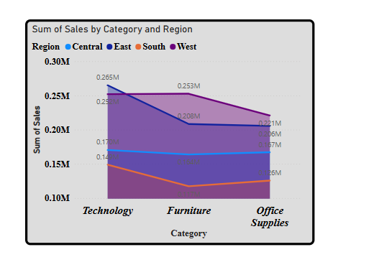’

stacked area charts

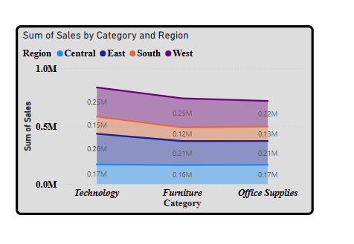

100% stacked area charts

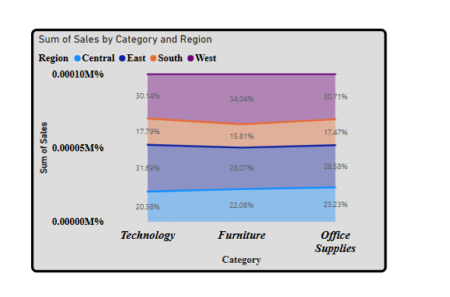

line charts

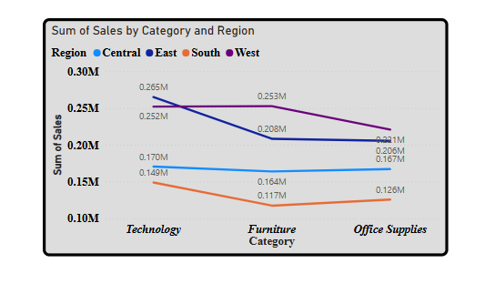

line and clusted column carts

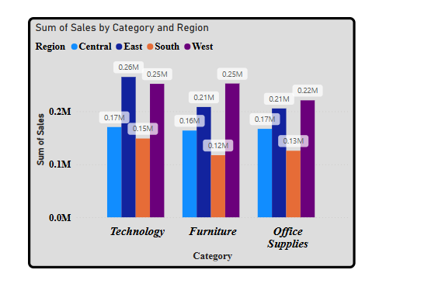

stacked column charts

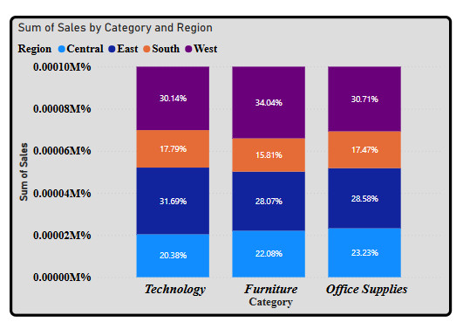

Ribbon charts

9